**Problem Statement**

ER Diagram (description)

Tables with schema

Features

Relationships

Sample Data 8-10 SQL Queries

✅ **1. Project Title**

Bookstore Management System (SQL Only Project)

✅ **2. Problem Statement**

The objective of this project is to design and implement a **relational database system** for an online bookstore that efficiently manages book inventory, customer information, author details, and sales transactions. The database aims to streamline business operations, improve data accuracy, and enable easy access to key insights related to inventory, customers, and sales performance.

✅ **3. ER Diagram (Textual Description)**

**Entities:**

Books

Authors

Genres

Customers

Orders

Order Details

Payments

✅ **4. Relationships:**

A book can have one or more authors (1 : M)

A book belongs to one Genre (1 : 1)

A customer can place multiple orders (1 : M)

Each order has multiple items (1 : M)

Each Order Detail refers to a book (1 : 1)

Each order has one payment

✅ **5.Features**

Book Inventory Management

Customer Details

Orders and Transactions

Authors and Categories

Payments and Stock Updates

✅ **6.Tables and Schema**

Here’s the structure in SQL DDL format

**CREATE DATABASE IF NOT EXISTS OnlineBookstoreDB**;

**CREATE TABLE Customers** (

Customer_ID INT PRIMARY KEY,

Name VARCHAR(255) NOT NULL,

Email VARCHAR(255) NOT NULL,

Phone VARCHAR(50),

Created_At TIMESTAMP NOT NULL DEFAULT CURRENT_TIMESTAMP,

Street VARCHAR(255),

City VARCHAR(100) NOT NULL,

State VARCHAR(100),

Postal_Code VARCHAR(20) NOT NULL,

Country VARCHAR(50) NOT NULL);

**CREATE TABLE Authors** (

Author_ID INT PRIMARY KEY,

Name VARCHAR(255) NOT NULL,

Bio TEXT);

**CREATE TABLE Genres** (

Genre_ID INT PRIMARY KEY,

Genre_Name VARCHAR(100) NOT NULL UNIQUE);

**CREATE TABLE Books** (

Book_ID INT PRIMARY KEY,

Title VARCHAR(255) NOT NULL,

Author_ID INT NOT NULL,

Genre_ID INT NOT NULL,

Price DECIMAL(10,2) NOT NULL DEFAULT 0.00,

Stock_Quantity INT NOT NULL DEFAULT 0,

CONSTRAINT fk_author FOREIGN KEY (Author_ID) REFERENCES Authors(Author_ID),

CONSTRAINT fk_genre FOREIGN KEY (Genre_ID) REFERENCES Genres(Genre_ID));

**CREATE INDEX** idx_books_title ON Books(Title);

**CREATE TABLE Orders** (

Order_ID INT PRIMARY KEY,

Customer_ID INT NOT NULL,

Order_Date DATETIME NOT NULL DEFAULT CURRENT_TIMESTAMP,

Total_Amount DECIMAL(10,2) NOT NULL DEFAULT 0.00,

CONSTRAINT fk_customer FOREIGN KEY (Customer_ID) REFERENCES Customers(Customer_ID));

**CREATE INDEX** idx_orders_customer_id ON Orders(Customer_ID);

**CREATE TABLE OrderDetails** (

Order_ID INT NOT NULL,

Book_ID INT NOT NULL,

Quantity INT NOT NULL DEFAULT 1,

Price DECIMAL(10,2) NOT NULL DEFAULT 0.00,

PRIMARY KEY (Order_ID, Book_ID),

CONSTRAINT fk_orderdetails_order FOREIGN KEY (Order_ID) REFERENCES Orders(Order_ID),

CONSTRAINT fk_orderdetails_book FOREIGN KEY (Book_ID) REFERENCES Books(Book_ID));

**CREATE INDEX** idx_orderdetails_order_id ON OrderDetails(Order_ID);

**CREATE TABLE Payments** (

Payment_ID INT PRIMARY KEY,

Order_ID INT NOT NULL,

Payment_Method ENUM('Cash', 'Credit Card', 'Debit Card', 'Paypal', 'Other') NOT NULL DEFAULT 'Cash',

Payment_Status ENUM('Pending', 'Completed', 'Failed', 'Refunded') NOT NULL DEFAULT 'Pending',

Payment_Date DATETIME NOT NULL DEFAULT CURRENT_TIMESTAMP,

CONSTRAINT fk_payment_order FOREIGN KEY (Order_ID) REFERENCES Orders(Order_ID));

✅ **7. Roles & Permissions**

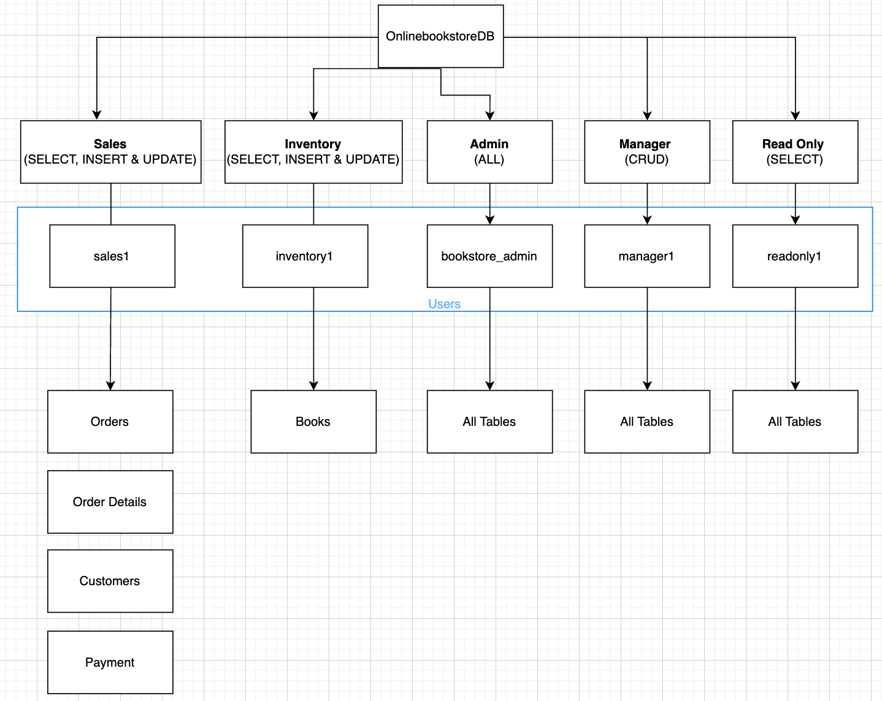

✅ **8.Sample Data Generation**

Sample data is extracted from AI, with a sample data for 500rows.

✅ **9. Data Analysis Queries for the following Topics**

**Sales Performance**

1. Which books generated the highest total revenue this year?

2. Who are the top 5 authors by total book sales?

3. What is the total monthly sales trend over the past year?

4. How many unique customers made purchases in the month of June'25?

**Inventory & Supply**

5. Which books are running low on stock and need restocking?

6. What is the total value of current inventory (price × stock)?

👩‍💻 **Customer Insights**

7. Who are the top 10 customers based on total spending?

8. Find the Customers who ordered the most books?

💡 **Business Optimization**

9. Which book categories or genres generate the most revenue?

10. Which books have not been sold in the last 6 months (slow movers)?